CODE:
a = 2
b = 3
c = a + b
print(c)
OUTPUT:

CODE:
a = int(input("Enter a: "))
b = int(input("Enter b: "))
c = a + b
print("a + b =",c)
OUTPUT:
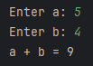
CODE:
a = ["Ashlon", 8, 19, "24IT08"]
for i in a:
print(i)
n = 0
while n < len(a):
print(a[n])
n+=1
OUTPUT:
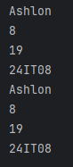
CODE:
a = ["Ashlon", "Arya", "Divyanshu", "Esben", "Nishtha"]
n = input("Enter a name to search: ")
if n in a:
print(n, "found in list.")
else:
print(n, "not found.")
OUTPUT:
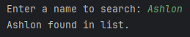

CODE:
A = [[1,2,3], [4,5,6], [7,8,9]]
B = [[9,8,7], [6,5,4], [3,2,1]]
result = [[0 for a in range(3)]for a in range(3)]
for i in range(3):
for j in range(3):
for k in range(3):
result[i][j] += A[i][k] * B[k][j]
print("Result =")
for r in result:
print(r)
OUTPUT:
